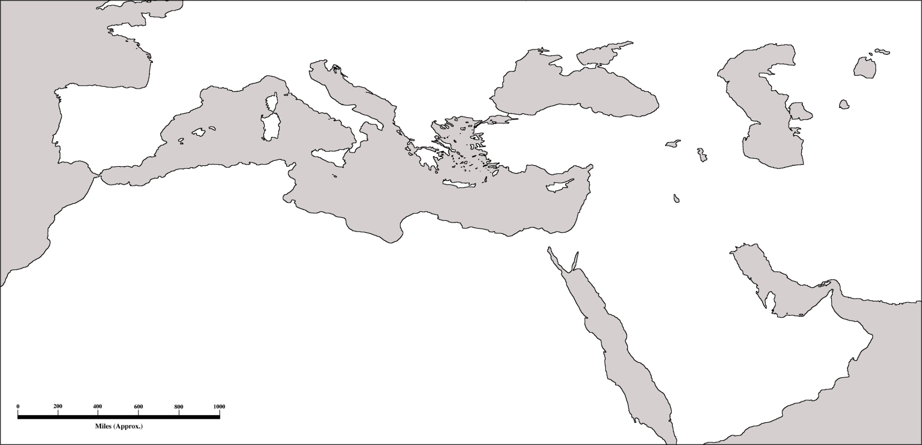

Chapter 18 – Expansion of the Muslim World, 1300-1700

Map Directions:
- Locate and label the following cities (8): Istanbul, Jerusalem, Baghdad, Cairo, Adrianople, Athens, Tehran, Esfahan
- Locate & Label the following geographic features (6): Black Sea, Caspian Sea, Persian Gulf, Red Sea, Aral Sea, Caucasus Mountains
- Locate& Label the following regions (7): Egypt, Balkans, Mesopotamia, Crimea, Persia, Greece, Arabia
- Color and/or shade (3): Ottoman Empire in 1451, all Ottoman acquisitions by 1566, Safavid Empire
- Create a key (1)

POINTS: ___/25

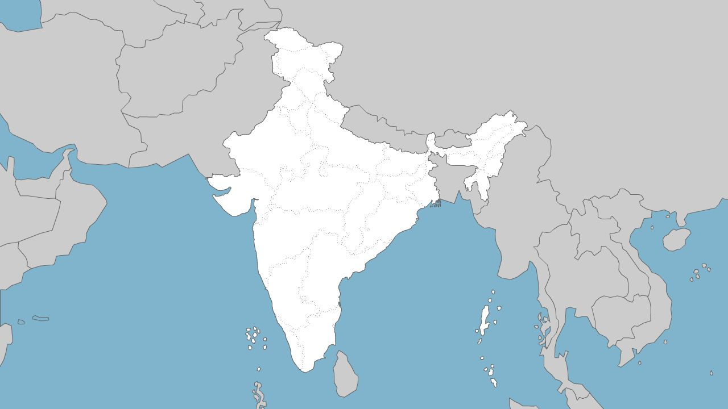
Map Directions:
- Locate and label the following cities (5): Kabul, Delhi, Bombay, Calcutta, Madras
- Locate & Label the following geographic features (4): Arabian Sea, Bay of Bengal, Deccan Plateau, Himalayas
- Locate& Label the following regions (3): Kashmir, Punjab, Ceylon
- Color and/or shade (2): Mughal Empire, 1526, all areas added by 1707 (Aurangzeb)
- Create a key (1)

POINTS: ___/15

