Ch. 17 – Renaissance Map
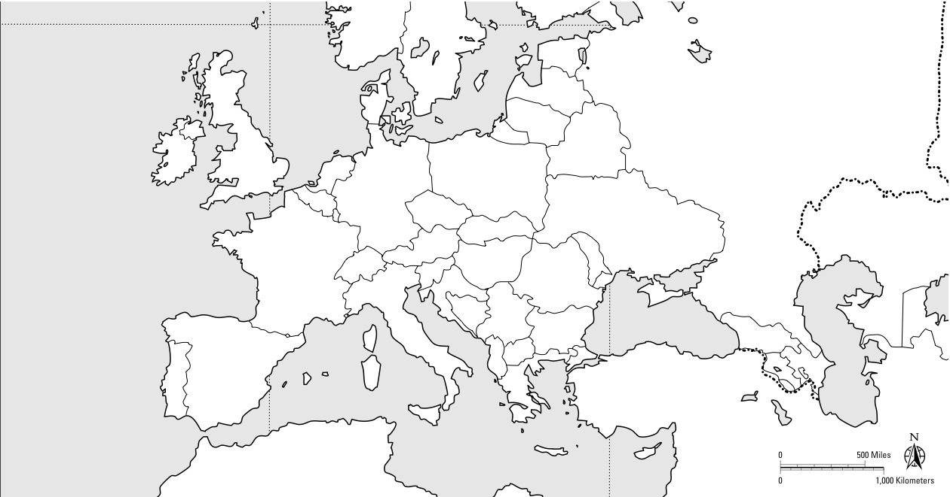

Directions:
- Cities (6): Paris, London, Rome, Florence, Milan, Venice
- Bodies of Water (3): Atlantic Ocean, North Sea, Mediterranean Sea
- Countries – Shade/Color (5): France, Spain, England, the Holy Roman Empire, & the Papal States
- Map Key (1)

Total Points: __/15
Ch. 17 – Reformation Map

Directions:
- Cities (7): Avignon, Worms, Wittenberg, Constantinople, Vienna, Madrid, Geneva
- Religions – Shade/Color (7): Roman Catholic, Lutheran, Anglican, Calvinist, Mixed Lands, Eastern Orthodox, Islam
- Map Key (1)

Total Points: __/15

