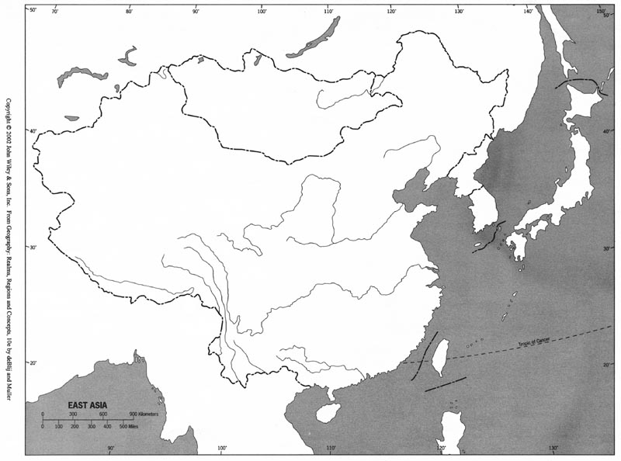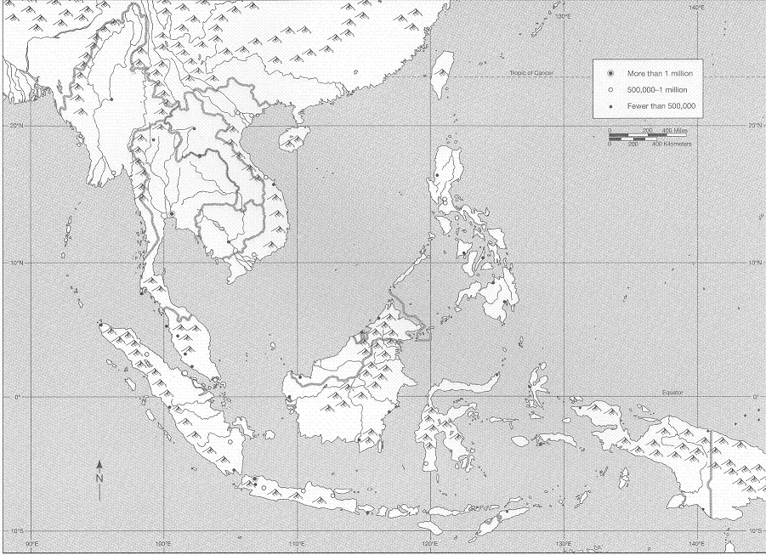

Map: China, Japan, & Korea
Countries (4): China, Korea, Mongolia, Japan
Cities, Areas, & Objects (8): Hangzhou, Guangzhou, Heian, Yangzhou, Beijing, Edo, Gobi Desert, the Himalayas
Bodies of Water (6): Chang Jiang River, Huang He River, Yellow Sea, East China Sea, Sea of Japan, Pacific Ocean
Color/Shade Areas (4): Japan (1100), Koryu Dynasty (1100), Mongol Homeland (1200), Song China (1100)
Key (1)

Map: Southeast Asia
Countries (2): Vietnam, the Philippines
Cities & Areas (7): Angkor, Hanoi, Sumatra, Borneo, Java, Malay Peninsula, the Equator
Bodies of Water (4): Bay of Bengal, South China Sea, Sunda Strait, Strait of Malacca
Color/Shade Areas (3): Khmer (1100), Vietnam (1200), Srivijaya (1200)
Key (1)
Total: __/40

Map: China, Japan, & Korea
Countries (4): China, Korea, Mongolia, Japan
Cities, Areas, & Objects (8): Hangzhou, Guangzhou, Heian, Yangzhou, Beijing, Edo, Gobi Desert, the Himalayas
Bodies of Water (6): Chang Jiang River, Huang He River, Yellow Sea, East China Sea, Sea of Japan, Pacific Ocean
Color/Shade Areas (4): Japan (1100), Koryu Dynasty (1100), Mongol Homeland (1200), Song China (1100)
Key (1)

Map: Southeast Asia
Countries (2): Vietnam, the Philippines
Cities & Areas (7): Angkor, Hanoi, Sumatra, Borneo, Java, Malay Peninsula, the Equator
Bodies of Water (4): Bay of Bengal, South China Sea, Sunda Strait, Strait of Malacca
Color/Shade Areas (3): Khmer (1100), Vietnam (1200), Srivijaya (1200)
Key (1)
Total: __/40

