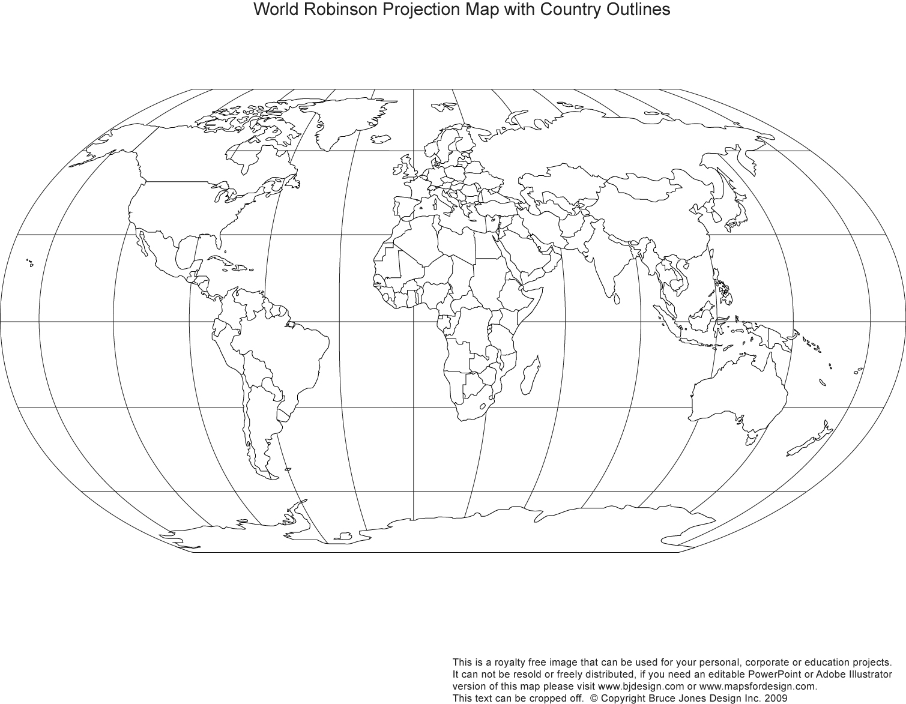
Ch. 19 Map – Age of Exploration & Isolation
Key:

Directions:
- Cities/Places (5): Lisbon, Mozambique, Calicut, Macau, Cape of Good Hope
- Explorers (3): Dias (1487-8), da Gama (1497-8), Zheng He (1405-33)
- Bodies of Water (4): Atlantic Ocean, Indian Ocean, Pacific Ocean, Arabian Sea
- Countries – Shade/Color (7): France, England, Netherlands, Spain, Portugal, China, Japan, Ottoman Empire
- European Overseas Territories (4): Dutch, French, Spanish, Portuguese (*same color as above*)
- Map Key (1)

Total Points: __/25

